## Rhutuja Patil

Roll no: 24

## **Practical 9: Registry Editor**

* **Accessing the Registry, Type regedit in Start Search**

**Wireless Evidence in the Registry HKEY_LOCAL_MACHINE\SOFTWARE\Microsoft\WindowsNT\CurrentVersion\NetworkList\Profiles**

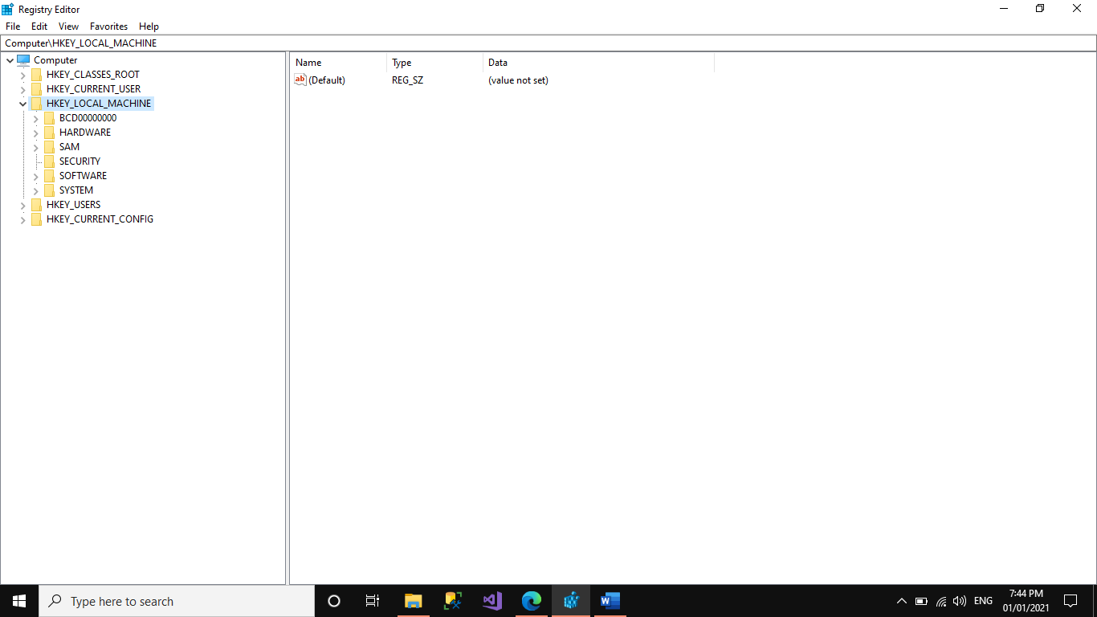

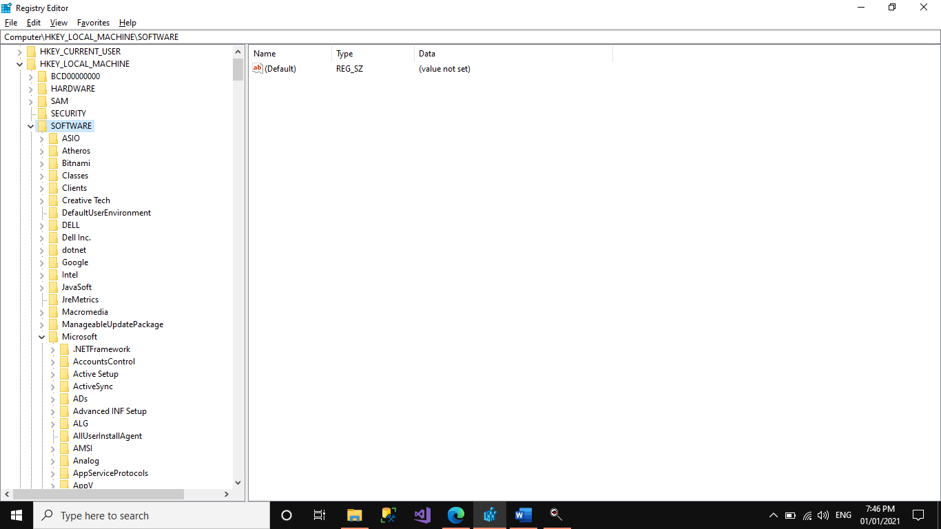

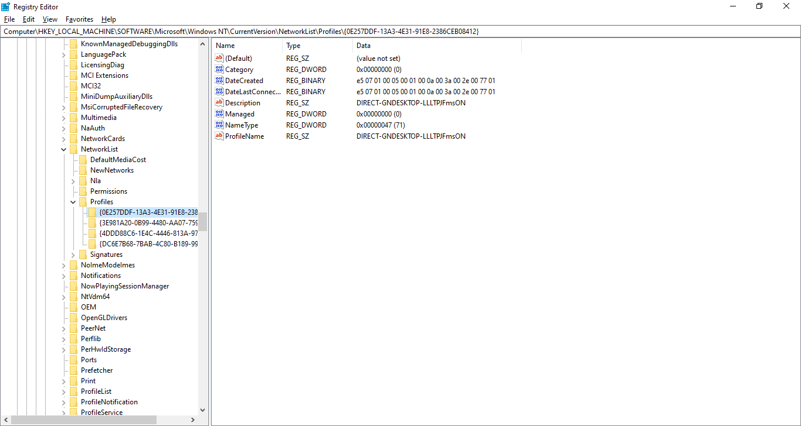

* **The RecentDocs Key HKEY_CURRENT_USER\Software\Microsoft\Windows\CurrentVersion\Explorer\RecentDocs**

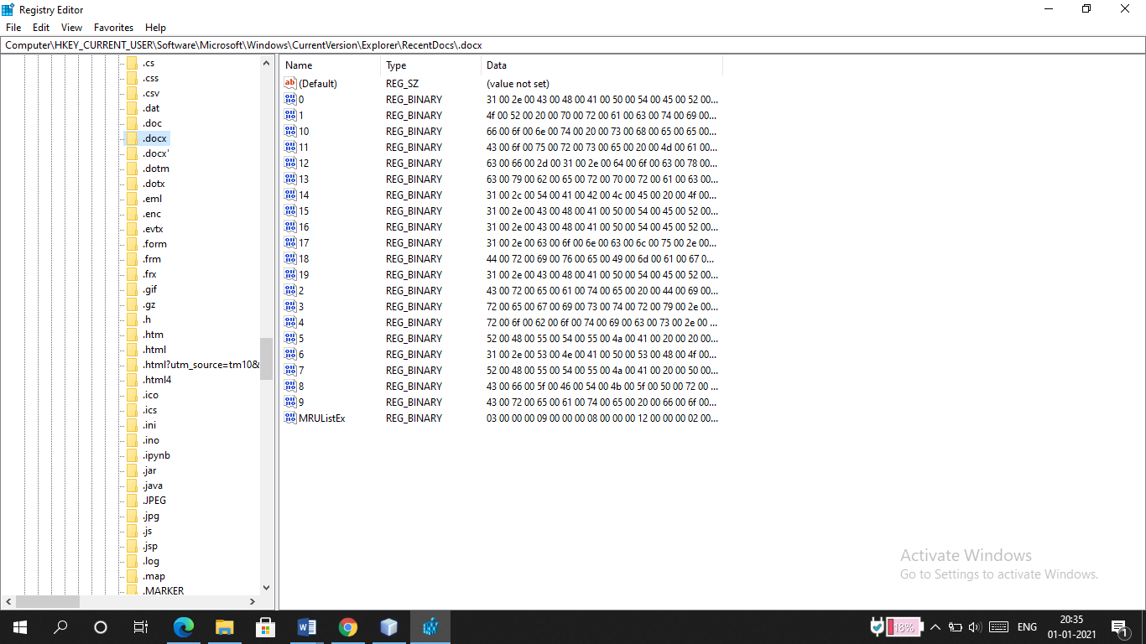

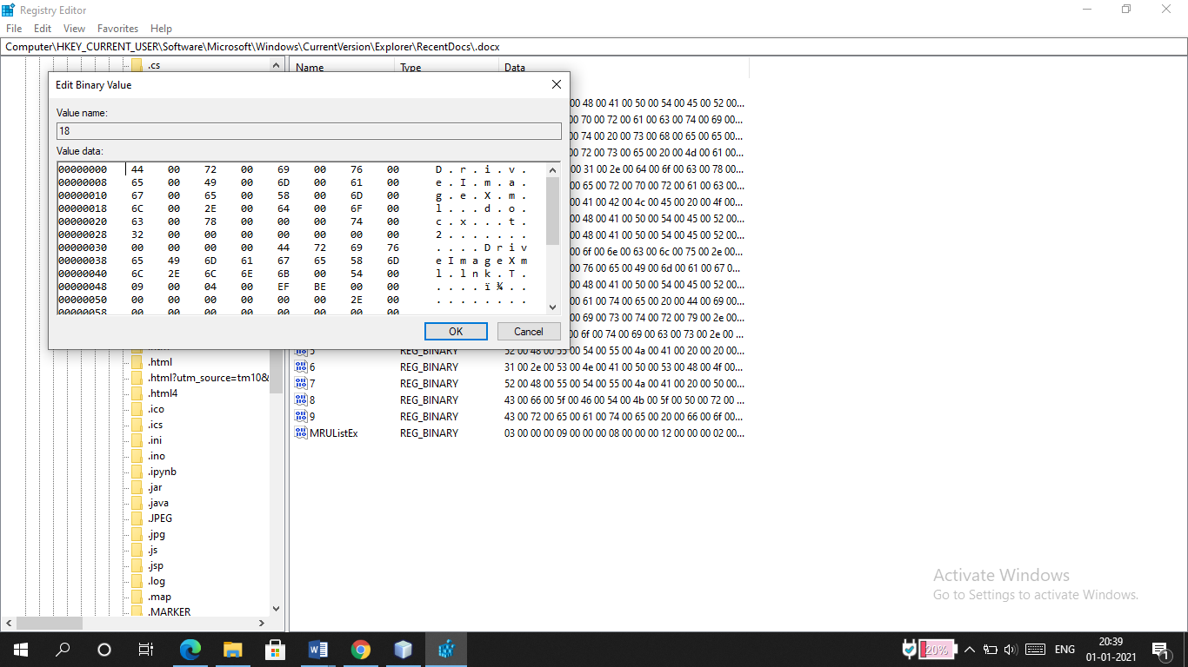

* **TypedURLs Key:**

**HKEY_CURRENT_USER\Software\Microsoft\Internet Explorer\TypedURLs**

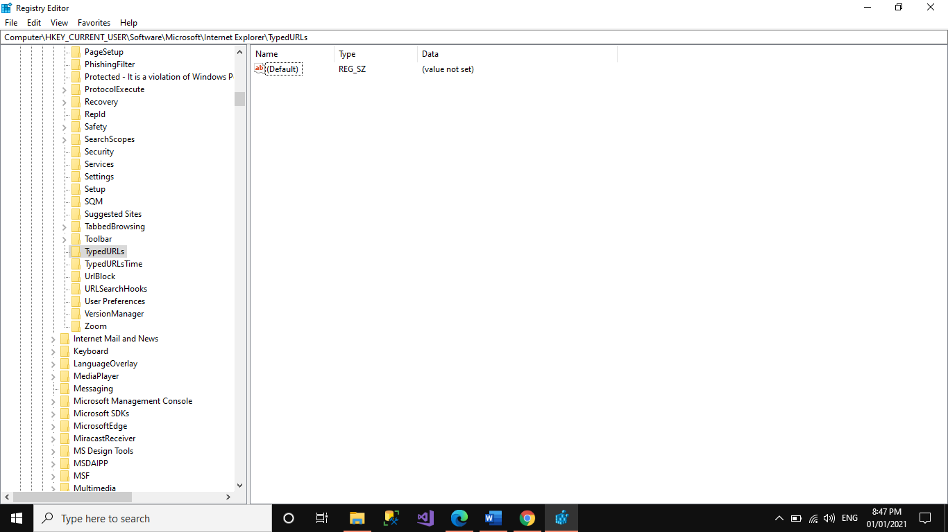

* **IP Addresses HKEY_LOCAL_MACHINE\System\Services\CurrentControlSet\services\Tcpip\Parameters\Interface**

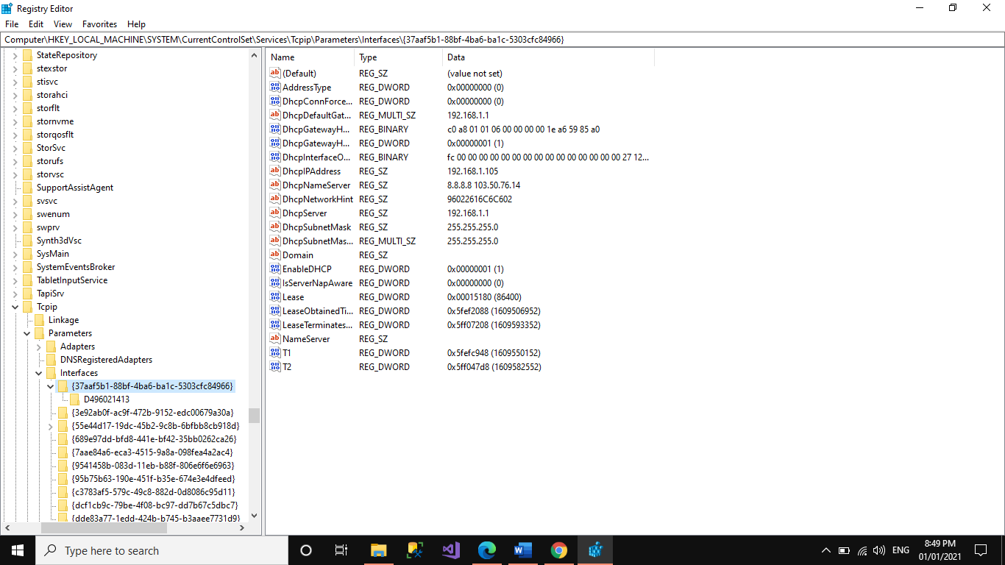

* **Start Up Locations in the Registry HKEY_LOCAL_MACHINE\Software\Microsoft\Windows\CurrentVersion\Run**

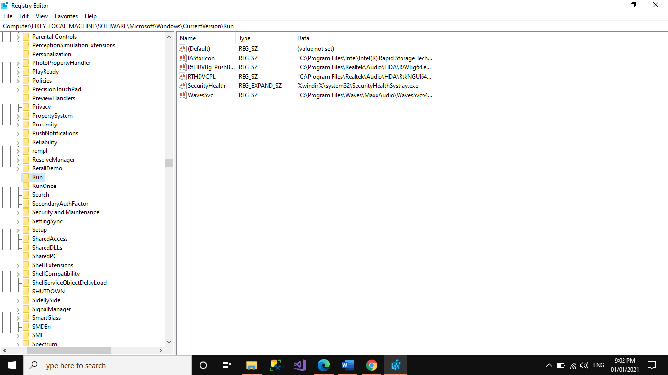

* **RunOnce Startup**

**HKEY_LOCAL_MACHINE\Software\Microsoft\Windows\CurrentVersion\RunOnce**

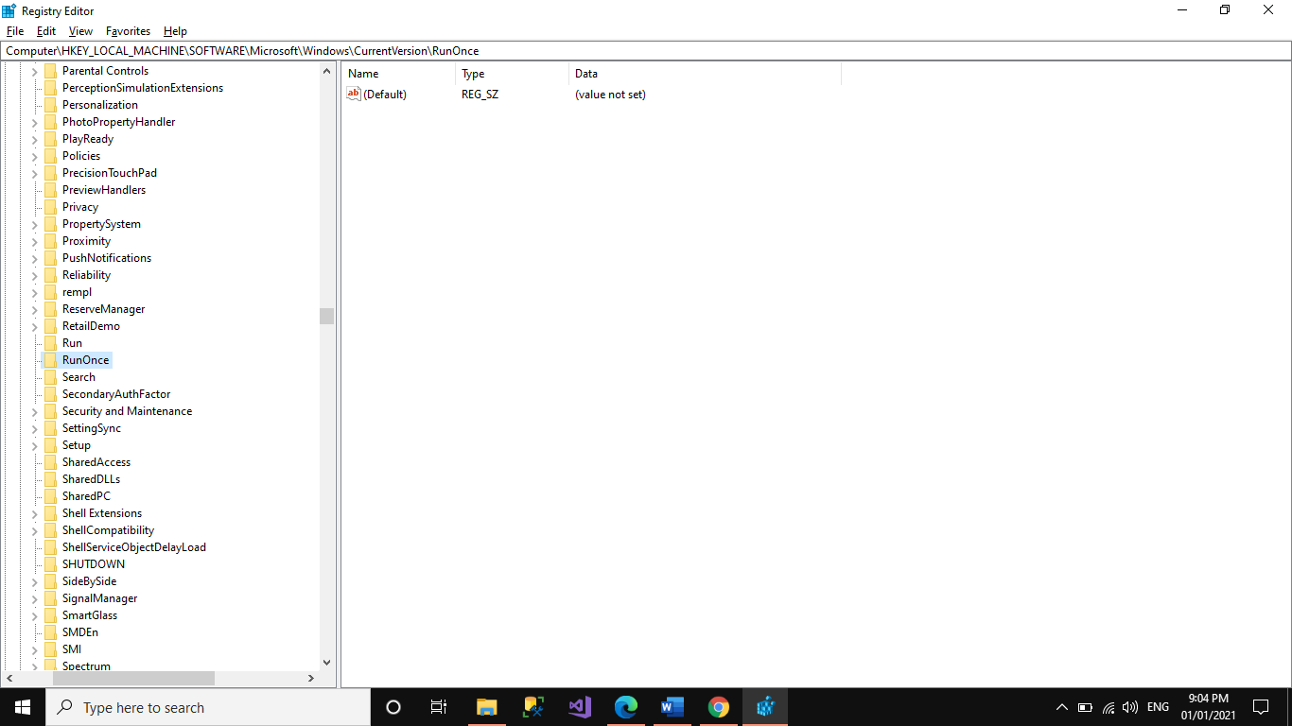

* **Start Up Services**

**HKEY_LOCAL_MACHINE\System\CurrentControlSet\Services**

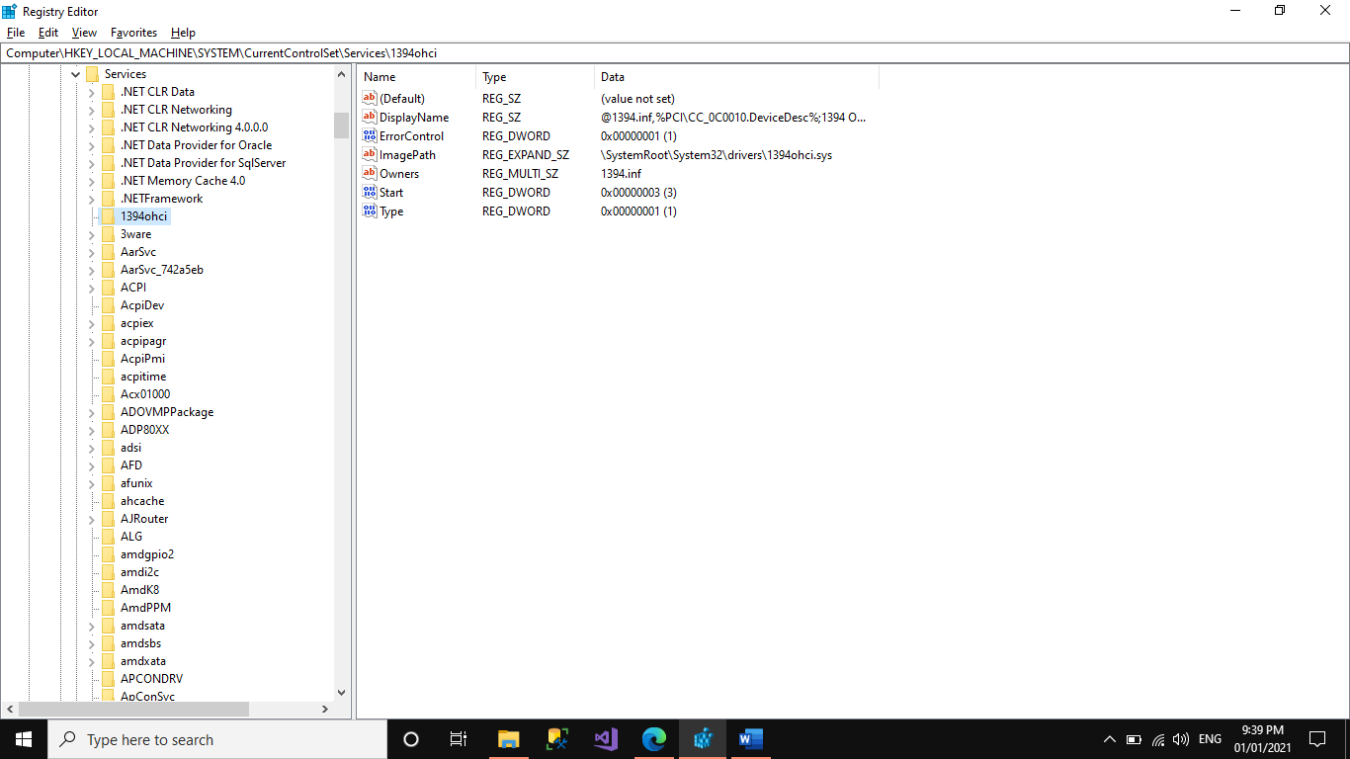

* **Start Legacy Applications**

**HKEY_LOCAL_MACHINE\System\CurrentControlSet\Control\WDI**

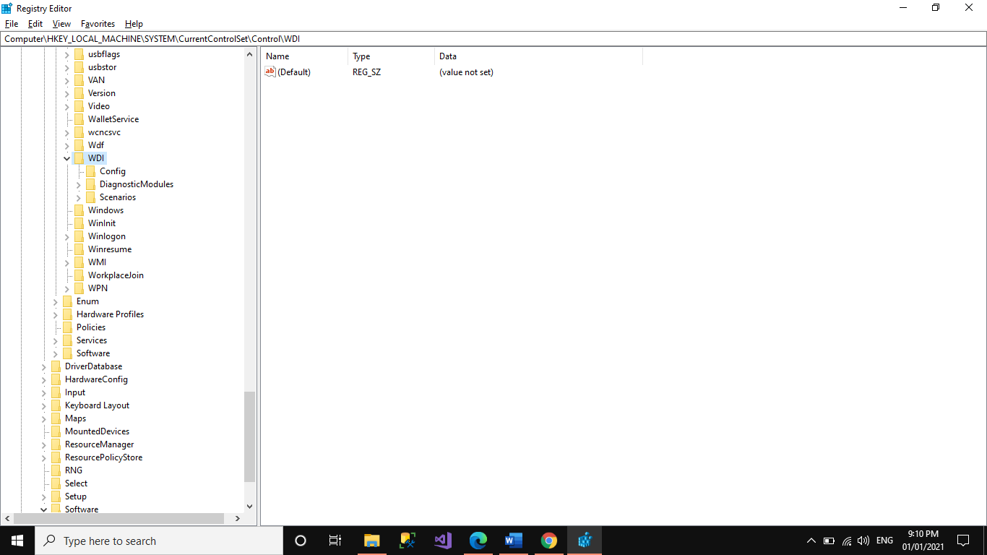

* **Start When a Particular User Logs On HKEY_CURRENT_USER\Software\Microsoft\Windows\CurrentVersion\Run**

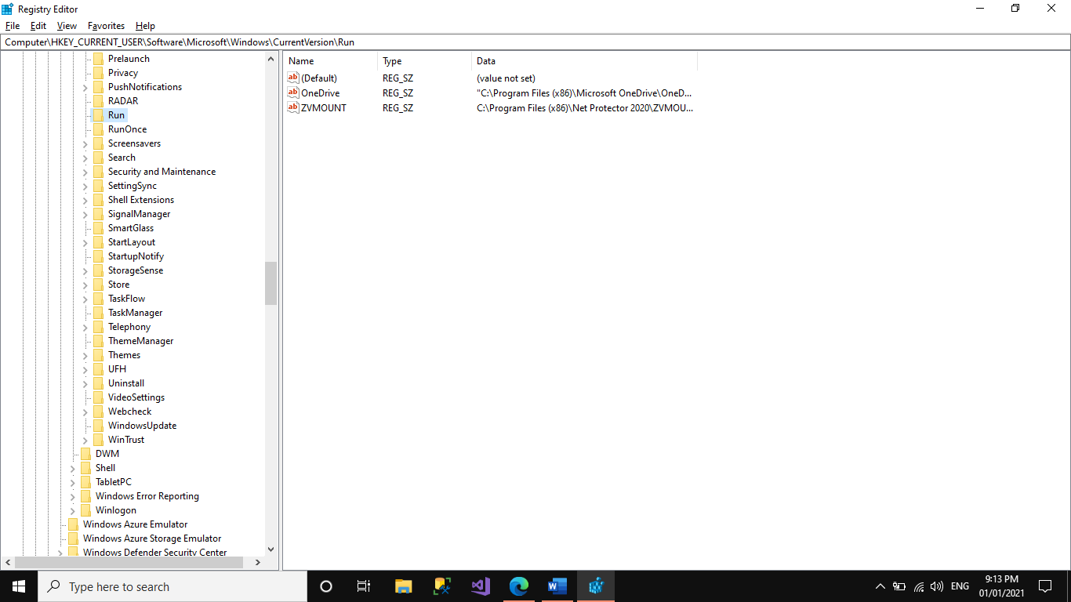

* **USB Storage Devices**

**HKEY_Local_Machine\System\ControlSet\Enum\USBSTOR**

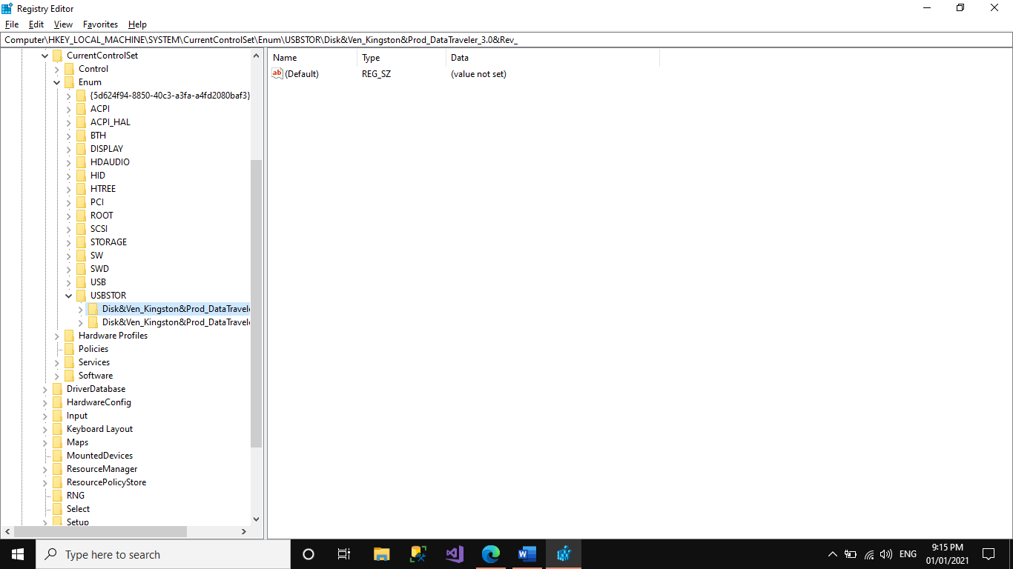

* **Mounted Devices**

**HKEY_LOCAL_MACHINE\System\MountedDevices**

